/* Analyze the data by finding the answers to the questions below:

1.Find the top 3 customers who have the maximum count of orders.

*/

SELECT

TOP 3 *

FROM(

SELECT

DISTINCT B.cust_id, first_name, last_name,

COUNT(ord_id) OVER(PARTITION BY B.cust_id) AS cnt_order

FROM

customer.customer_table AS A,

[order].order_table AS B

WHERE

A.cust_id = B.cust_id

) AS Subquery

ORDER BY cnt_order DESC

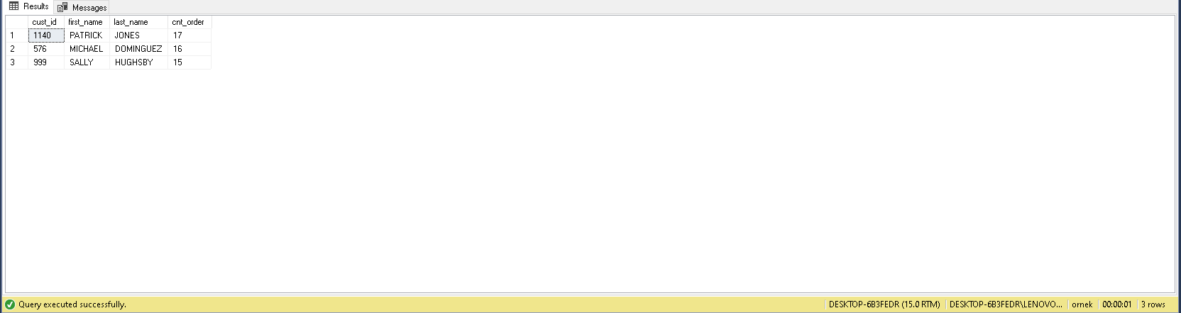

/* 2. Find the customer whose order took the maximum time to get shipping. */

WITH T1 AS(

SELECT

A.first_name,

A.last_name,

C.days_taken_for_shipping

FROM

customer.customer_table AS A

INNER JOIN [order].order_table AS B ON B.cust_id = A.cust_id

INNER JOIN customer.ship_table AS C ON C.ship_id = B.ship_id)

SELECT

TOP 1 *

FROM

T1

ORDER BY

days_taken_for_shipping DESC

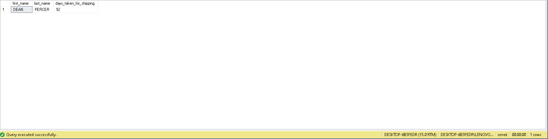

/* 3. Count the total number of unique customers in January and how many of them came back every month over the entire year in 2011 */

WITH T1 AS(

SELECT

A.*,

DATENAME(MONTH, B.order_date) AS month_name

FROM

customer.customer_table AS A

INNER JOIN [order].order_table AS B ON B.cust_id = A.cust_id

WHERE

YEAR(B.order_date) = 2011 AND

A.cust_id IN(

SELECT

DISTINCT A.cust_id

FROM

customer.customer_table AS A

INNER JOIN [order].order_table AS B ON B.cust_id = A.cust_id

WHERE

YEAR(B.order_date) = 2011 AND MONTH(B.order_date) = 1 ))

SELECT

SUM(CASE WHEN month_name = 'January' THEN 1 ELSE 0 END) AS January,

SUM(CASE WHEN month_name = 'February' THEN 1 ELSE 0 END) AS February,

SUM(CASE WHEN month_name = 'March' THEN 1 ELSE 0 END) AS March,

SUM(CASE WHEN month_name = 'April' THEN 1 ELSE 0 END) AS April,

SUM(CASE WHEN month_name = 'May' THEN 1 ELSE 0 END) AS May,

SUM(CASE WHEN month_name = 'June' THEN 1 ELSE 0 END) AS June,

SUM(CASE WHEN month_name = 'July' THEN 1 ELSE 0 END) AS July,

SUM(CASE WHEN month_name = 'August' THEN 1 ELSE 0 END) AS August,

SUM(CASE WHEN month_name = 'September' THEN 1 ELSE 0 END) AS September,

SUM(CASE WHEN month_name = 'October' THEN 1 ELSE 0 END) AS October,

SUM(CASE WHEN month_name = 'November' THEN 1 ELSE 0 END) AS November,

SUM(CASE WHEN month_name = 'December' THEN 1 ELSE 0 END) AS December

FROM

T1

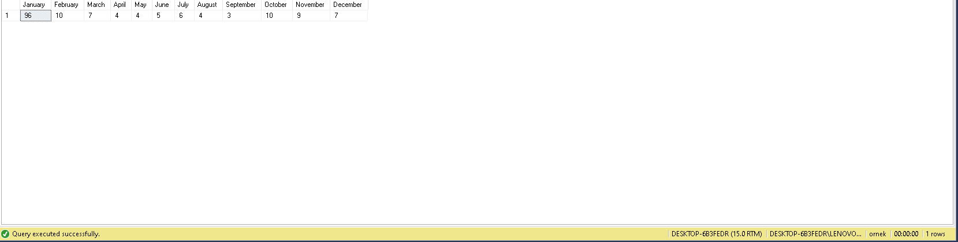

/* 4. Write a query to return for each user the time elapsed between the first purchasing and the third purchasing, in ascending order by Customer ID. */

SELECT

*,

DATEDIFF(DAY, first_purchasing, third_purchasing) AS difference_first_and_third_purchase

FROM(

SELECT

A.cust_id,

order_date AS first_purchasing,

LEAD(order_date, 2) OVER(PARTITION BY A.cust_id ORDER BY B.order_date) AS third_purchasing

FROM

customer.customer_table AS A

INNER JOIN [order].order_table AS B ON B.cust_id = A.cust_id) AS subquery

WHERE

third_purchasing IS NOT NULL

ORDER BY

cust_id;

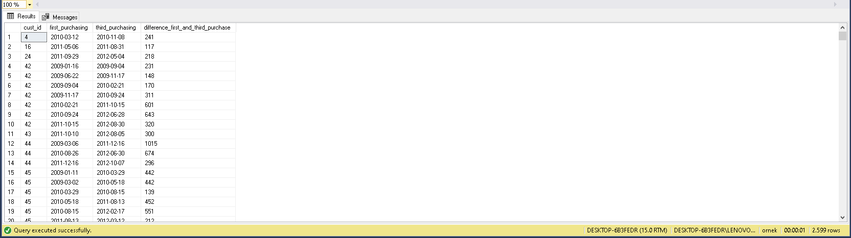

/* 5 . Write a query that returns customers who purchased both product 11 and product 14, as well as the ratio of these products to the total number of products purchased by the customer. */

GO

WITH T1 AS (

SELECT

DISTINCT A.cust_id,

SUM(C.order_quantity) OVER(PARTITION BY A.cust_id) AS prod_id_11,

A.first_name,

A.last_name

---CASE WHEN C.prod_id = 11 AND C.order_quantity ! = 0 THEN SUM(order_quantity) OVER(PARTITION BY A.cust_id) ELSE 0 END AS prod_id_11

FROM

customer.customer_table AS A

INNER JOIN [order].order_table AS B ON B.cust_id = A.cust_id

INNER JOIN [order].order_item AS C ON C.ord_id = B.ord_id

WHERE

C.prod_id = 11

), T2 AS(

SELECT

DISTINCT A.cust_id,

SUM(C.order_quantity) OVER(PARTITION BY A.cust_id) AS prod_id_14,

A.first_name,

A.last_name

---CASE WHEN C.prod_id = 14 AND C.order_quantity ! = 0 THEN SUM(order_quantity) OVER(PARTITION BY A.cust_id) ELSE 0 END AS prod_id_14

FROM

customer.customer_table AS A

INNER JOIN [order].order_table AS B ON B.cust_id = A.cust_id

INNER JOIN [order].order_item AS C ON C.ord_id = B.ord_id

WHERE

C.prod_id = 14

), T3 AS(

SELECT

DISTINCT A.cust_id,

SUM(C.order_quantity) OVER(PARTITION BY A.cust_id) AS sum_quantity,

A.first_name,

A.last_name

---CASE WHEN C.prod_id = 14 AND C.order_quantity ! = 0 THEN SUM(order_quantity) OVER(PARTITION BY A.cust_id) ELSE 0 END AS prod_id_14

FROM

customer.customer_table AS A

INNER JOIN [order].order_table AS B ON B.cust_id = A.cust_id

INNER JOIN [order].order_item AS C ON C.ord_id = B.ord_id

)

SELECT

T1.cust_id,

T1.first_name,

T1.last_name,

T3.sum_quantity,

T1.prod_id_11,

CAST(T1.prod_id_11 * 1.0 / T3.sum_quantity * 1.0 AS DECIMAL(3,2)) AS ratio_of_product_11,

T2.prod_id_14,

CAST(T2.prod_id_14 * 1.0 / T3.sum_quantity * 1.0 AS DECIMAL(3,2)) AS ratio_of_product_14

FROM

T1

INNER JOIN T2 ON T1.cust_id = T2.cust_id

INNER JOIN T3 ON T3.cust_id = T2.cust_id

ORDER BY

T1.cust_id

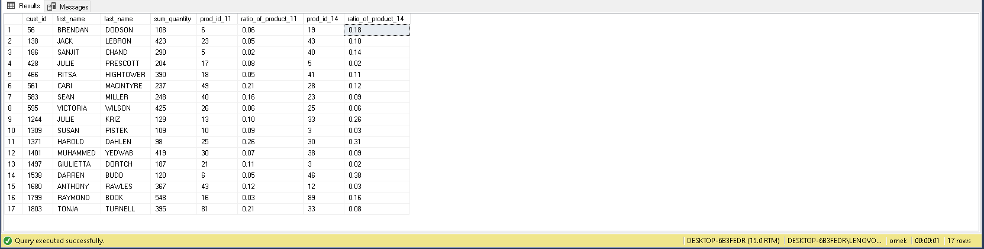

**Customer Segmentation**

**Categorize customers based on their frequency of visits. The following steps will guide you. If you want, you can track your own way.**

/* 1. Create a “view” that keeps visit logs of customers on a monthly basis. (For each log, three field is kept: Cust_id, Year, Month) */

GO

;CREATE VIEW vw_visit_logs AS(

SELECT

DISTINCT cust_id,

YEAR(order_date) AS 'year',

MONTH(order_date) AS 'month'

FROM

[order].order_table)

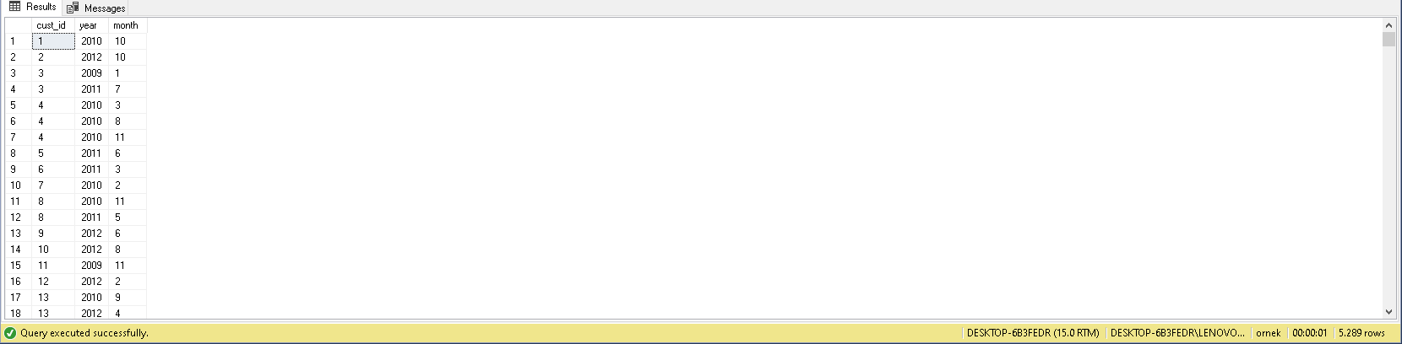

/* 2. Create a “view” that keeps the number of monthly visits by users. (Show separately all months from the beginning business) */

CREATE VIEW vw_number_of_visits AS(

SELECT

cust_id,

[2009_January], [2009_February], [2009_March], [2009_April], [2009_May], [2009_June], [2009_July],[2009_August], [2009_September], [2009_October], [2009_November], [2009_December],

[2010_January], [2010_February], [2010_March], [2010_April], [2010_May], [2010_June], [2010_July],[2010_August], [2010_September], [2010_October], [2010_November], [2010_December],

[2011_January], [2011_February], [2011_March], [2011_April], [2011_May], [2011_June], [2011_July],[2011_August], [2011_September], [2011_October], [2011_November], [2011_December],

[2012_January], [2012_February], [2012_March], [2012_April], [2012_May], [2012_June], [2012_July],[2012_August], [2012_September], [2012_October], [2012_November], [2012_December]

FROM (

SELECT

cust_id,

CONCAT(YEAR(order_date), '_', DATENAME(MONTH, order_date)) AS YearMonth

FROM

[order].order_table

) AS subquery

PIVOT (

COUNT(YearMonth)

FOR YearMonth IN (

[2009_January], [2009_February], [2009_March], [2009_April], [2009_May], [2009_June], [2009_July],[2009_August], [2009_September], [2009_October], [2009_November], [2009_December],

[2010_January], [2010_February], [2010_March], [2010_April], [2010_May], [2010_June], [2010_July],[2010_August], [2010_September], [2010_October], [2010_November], [2010_December],

[2011_January], [2011_February], [2011_March], [2011_April], [2011_May], [2011_June], [2011_July],[2011_August], [2011_September], [2011_October], [2011_November], [2011_December],

[2012_January], [2012_February], [2012_March], [2012_April], [2012_May], [2012_June], [2012_July],[2012_August], [2012_September], [2012_October], [2012_November], [2012_December]

)

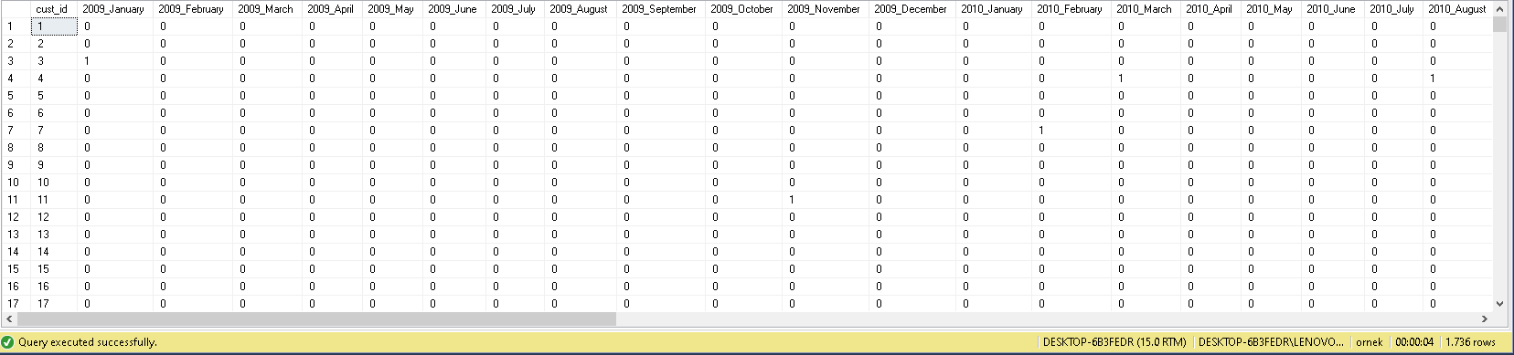) AS pivot_table);

/* 3. For each visit of customers, create the next month of the visit as a separate column. */

SELECT

DISTINCT cust_id,

order_date AS [1_visit],

LEAD(order_date) OVER(PARTITION BY cust_id ORDER BY order_date) [2_visit],

LEAD(order_date, 2) OVER(PARTITION BY cust_id ORDER BY order_date) [3_visit],

LEAD(order_date,3) OVER(PARTITION BY cust_id ORDER BY order_date) [4_visit],

LEAD(order_date, 4) OVER(PARTITION BY cust_id ORDER BY order_date) [5_visit],

LEAD(order_date, 5) OVER(PARTITION BY cust_id ORDER BY order_date) [6_visit],

LEAD(order_date, 6) OVER(PARTITION BY cust_id ORDER BY order_date) [7_visit],

LEAD(order_date, 7) OVER(PARTITION BY cust_id ORDER BY order_date) [8_visit],

LEAD(order_date, 8) OVER(PARTITION BY cust_id ORDER BY order_date) [9_visit],

LEAD(order_date, 9) OVER(PARTITION BY cust_id ORDER BY order_date) [10_visit],

LEAD(order_date, 10) OVER(PARTITION BY cust_id ORDER BY order_date) [11_visit],

LEAD(order_date, 11) OVER(PARTITION BY cust_id ORDER BY order_date) [12_visit],

LEAD(order_date, 12) OVER(PARTITION BY cust_id ORDER BY order_date) [13_visit],

LEAD(order_date, 13) OVER(PARTITION BY cust_id ORDER BY order_date) [14_visit],

LEAD(order_date, 14) OVER(PARTITION BY cust_id ORDER BY order_date) [15_visit],

LEAD(order_date, 15) OVER(PARTITION BY cust_id ORDER BY order_date) [16_visit],

LEAD(order_date, 16) OVER(PARTITION BY cust_id ORDER BY order_date) [17_visit]

FROM

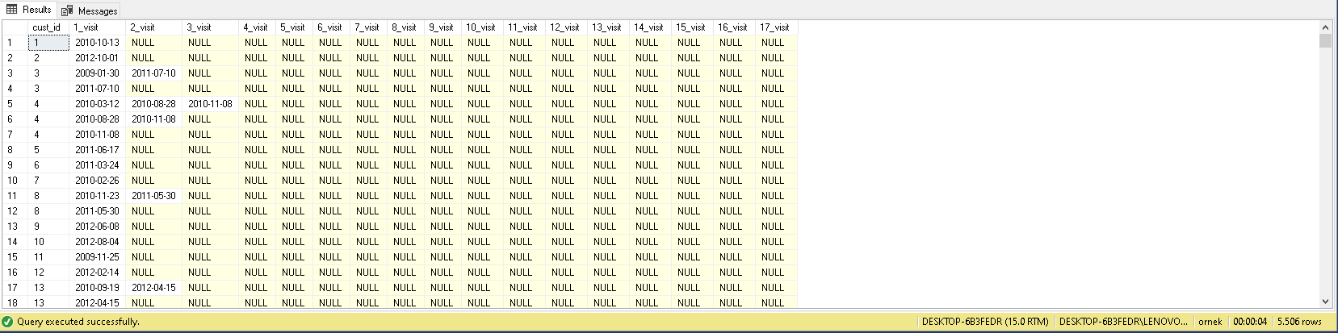 [order].order_table

/* 4. Calculate the monthly time gap between two consecutive visits by each customer. */

WITH CTE AS (

SELECT

DISTINCT cust_id,

0 AS [1_visit],

DATEDIFF(MONTH ,order_date, LEAD(order_date) OVER(PARTITION BY cust_id ORDER BY order_date)) AS [1_gap],

DATEDIFF(MONTH , LEAD(order_date) OVER(PARTITION BY cust_id ORDER BY order_date), LEAD(order_date, 2) OVER(PARTITION BY cust_id ORDER BY order_date)) AS [2_gap],

DATEDIFF(MONTH , LEAD(order_date, 2) OVER(PARTITION BY cust_id ORDER BY order_date), LEAD(order_date, 3) OVER(PARTITION BY cust_id ORDER BY order_date)) AS [3_gap],

DATEDIFF(MONTH , LEAD(order_date, 3) OVER(PARTITION BY cust_id ORDER BY order_date), LEAD(order_date, 4) OVER(PARTITION BY cust_id ORDER BY order_date)) AS [4_gap],

DATEDIFF(MONTH , LEAD(order_date, 4) OVER(PARTITION BY cust_id ORDER BY order_date), LEAD(order_date, 5) OVER(PARTITION BY cust_id ORDER BY order_date)) AS [5_gap],

DATEDIFF(MONTH , LEAD(order_date, 5) OVER(PARTITION BY cust_id ORDER BY order_date), LEAD(order_date, 6) OVER(PARTITION BY cust_id ORDER BY order_date)) AS [6_gap],

DATEDIFF(MONTH , LEAD(order_date, 6) OVER(PARTITION BY cust_id ORDER BY order_date), LEAD(order_date, 7) OVER(PARTITION BY cust_id ORDER BY order_date)) AS [7_gap],

DATEDIFF(MONTH , LEAD(order_date, 7) OVER(PARTITION BY cust_id ORDER BY order_date), LEAD(order_date, 8) OVER(PARTITION BY cust_id ORDER BY order_date)) AS [8_gap],

DATEDIFF(MONTH , LEAD(order_date, 8) OVER(PARTITION BY cust_id ORDER BY order_date), LEAD(order_date, 9) OVER(PARTITION BY cust_id ORDER BY order_date)) AS [9_gap],

DATEDIFF(MONTH , LEAD(order_date, 9) OVER(PARTITION BY cust_id ORDER BY order_date), LEAD(order_date, 10) OVER(PARTITION BY cust_id ORDER BY order_date)) AS [10_gap],

DATEDIFF(MONTH , LEAD(order_date, 10) OVER(PARTITION BY cust_id ORDER BY order_date), LEAD(order_date, 11) OVER(PARTITION BY cust_id ORDER BY order_date)) AS [11_gap],

DATEDIFF(MONTH , LEAD(order_date, 11) OVER(PARTITION BY cust_id ORDER BY order_date), LEAD(order_date, 12) OVER(PARTITION BY cust_id ORDER BY order_date)) AS [12_gap],

DATEDIFF(MONTH , LEAD(order_date, 12) OVER(PARTITION BY cust_id ORDER BY order_date), LEAD(order_date, 13) OVER(PARTITION BY cust_id ORDER BY order_date)) AS [13_gap],

DATEDIFF(MONTH , LEAD(order_date, 13) OVER(PARTITION BY cust_id ORDER BY order_date), LEAD(order_date, 14) OVER(PARTITION BY cust_id ORDER BY order_date)) AS [14_gap],

DATEDIFF(MONTH , LEAD(order_date, 14) OVER(PARTITION BY cust_id ORDER BY order_date), LEAD(order_date, 15) OVER(PARTITION BY cust_id ORDER BY order_date)) AS [15_gap],

DATEDIFF(MONTH , LEAD(order_date, 15) OVER(PARTITION BY cust_id ORDER BY order_date), LEAD(order_date, 16) OVER(PARTITION BY cust_id ORDER BY order_date)) AS [16_gap]

FROM

[order].order_table

)

SELECT TOP 1 WITH TIES *

FROM CTE

ORDER BY RANK() OVER (PARTITION BY cust_id ORDER BY CASE WHEN [1_gap] IS NULL THEN 1 ELSE 0 END + CASE WHEN [2_gap] IS NULL THEN 1 ELSE 0 END + CASE WHEN [3_gap] IS NULL THEN 1 ELSE 0 END +CASE WHEN [4_gap] IS NULL THEN 1 ELSE 0 END +CASE WHEN [5_gap] IS NULL THEN 1 ELSE 0 END +CASE WHEN [6_gap] IS NULL THEN 1 ELSE 0 END +CASE WHEN [7_gap] IS NULL THEN 1 ELSE 0 END +CASE WHEN [8_gap] IS NULL THEN 1 ELSE 0 END +CASE WHEN [9_gap] IS NULL THEN 1 ELSE 0 END +CASE WHEN [10_gap] IS NULL THEN 1 ELSE 0 END + CASE WHEN [11_gap] IS NULL THEN 1 ELSE 0 END + CASE WHEN [12_gap] IS NULL THEN 1 ELSE 0 END + CASE WHEN [13_gap] IS NULL THEN 1 ELSE 0 END + CASE WHEN [14_gap] IS NULL THEN 1 ELSE 0 END + CASE WHEN [15_gap] IS NULL THEN 1 ELSE 0 END + CASE WHEN [16_gap] IS NULL THEN 1 ELSE 0 END + 0) ASC;

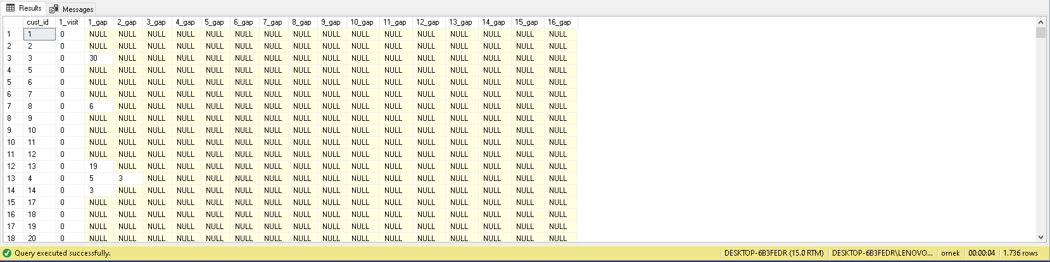

/* 5. Categorise customers using average time gaps. Choose the most fitted labeling model for you. */

--create a table with 'total_gaps_non_null' name

WITH CTE AS (

SELECT

DISTINCT cust_id,

0 AS [1_visit],

DATEDIFF(MONTH ,order_date, LEAD(order_date) OVER(PARTITION BY cust_id ORDER BY order_date)) AS [1_gap],

DATEDIFF(MONTH , LEAD(order_date) OVER(PARTITION BY cust_id ORDER BY order_date), LEAD(order_date, 2) OVER(PARTITION BY cust_id ORDER BY order_date)) AS [2_gap],

DATEDIFF(MONTH , LEAD(order_date, 2) OVER(PARTITION BY cust_id ORDER BY order_date), LEAD(order_date, 3) OVER(PARTITION BY cust_id ORDER BY order_date)) AS [3_gap],

DATEDIFF(MONTH , LEAD(order_date, 3) OVER(PARTITION BY cust_id ORDER BY order_date), LEAD(order_date, 4) OVER(PARTITION BY cust_id ORDER BY order_date)) AS [4_gap],

DATEDIFF(MONTH , LEAD(order_date, 4) OVER(PARTITION BY cust_id ORDER BY order_date), LEAD(order_date, 5) OVER(PARTITION BY cust_id ORDER BY order_date)) AS [5_gap],

DATEDIFF(MONTH , LEAD(order_date, 5) OVER(PARTITION BY cust_id ORDER BY order_date), LEAD(order_date, 6) OVER(PARTITION BY cust_id ORDER BY order_date)) AS [6_gap],

DATEDIFF(MONTH , LEAD(order_date, 6) OVER(PARTITION BY cust_id ORDER BY order_date), LEAD(order_date, 7) OVER(PARTITION BY cust_id ORDER BY order_date)) AS [7_gap],

DATEDIFF(MONTH , LEAD(order_date, 7) OVER(PARTITION BY cust_id ORDER BY order_date), LEAD(order_date, 8) OVER(PARTITION BY cust_id ORDER BY order_date)) AS [8_gap],

DATEDIFF(MONTH , LEAD(order_date, 8) OVER(PARTITION BY cust_id ORDER BY order_date), LEAD(order_date, 9) OVER(PARTITION BY cust_id ORDER BY order_date)) AS [9_gap],

DATEDIFF(MONTH , LEAD(order_date, 9) OVER(PARTITION BY cust_id ORDER BY order_date), LEAD(order_date, 10) OVER(PARTITION BY cust_id ORDER BY order_date)) AS [10_gap],

DATEDIFF(MONTH , LEAD(order_date, 10) OVER(PARTITION BY cust_id ORDER BY order_date), LEAD(order_date, 11) OVER(PARTITION BY cust_id ORDER BY order_date)) AS [11_gap],

DATEDIFF(MONTH , LEAD(order_date, 11) OVER(PARTITION BY cust_id ORDER BY order_date), LEAD(order_date, 12) OVER(PARTITION BY cust_id ORDER BY order_date)) AS [12_gap],

DATEDIFF(MONTH , LEAD(order_date, 12) OVER(PARTITION BY cust_id ORDER BY order_date), LEAD(order_date, 13) OVER(PARTITION BY cust_id ORDER BY order_date)) AS [13_gap],

DATEDIFF(MONTH , LEAD(order_date, 13) OVER(PARTITION BY cust_id ORDER BY order_date), LEAD(order_date, 14) OVER(PARTITION BY cust_id ORDER BY order_date)) AS [14_gap],

DATEDIFF(MONTH , LEAD(order_date, 14) OVER(PARTITION BY cust_id ORDER BY order_date), LEAD(order_date, 15) OVER(PARTITION BY cust_id ORDER BY order_date)) AS [15_gap],

DATEDIFF(MONTH , LEAD(order_date, 15) OVER(PARTITION BY cust_id ORDER BY order_date), LEAD(order_date, 16) OVER(PARTITION BY cust_id ORDER BY order_date)) AS [16_gap]

FROM

[order].order_table

)

SELECT TOP 1 WITH TIES *,

COALESCE([1_gap], 0) + COALESCE([2_gap], 0) + COALESCE([3_gap], 0) + COALESCE([3_gap], 0) + COALESCE([4_gap], 0) + COALESCE([5_gap], 0) + COALESCE([6_gap], 0) + COALESCE([7_gap], 0) + COALESCE([8_gap], 0) + COALESCE([9_gap], 0) + COALESCE([10_gap], 0) + COALESCE([11_gap], 0) + COALESCE([12_gap], 0) + COALESCE([13_gap], 0) + COALESCE([14_gap], 0) + COALESCE([15_gap], 0) + COALESCE([16_gap], 0) AS total_gap,

CASE WHEN [1_gap] IS NOT NULL THEN 1 ELSE 0 END +

CASE WHEN [2_gap] IS NOT NULL THEN 1 ELSE 0 END +

CASE WHEN [3_gap] IS NOT NULL THEN 1 ELSE 0 END +

CASE WHEN [4_gap] IS NOT NULL THEN 1 ELSE 0 END +

CASE WHEN [5_gap] IS NOT NULL THEN 1 ELSE 0 END +

CASE WHEN [6_gap] IS NOT NULL THEN 1 ELSE 0 END +

CASE WHEN [7_gap] IS NOT NULL THEN 1 ELSE 0 END +

CASE WHEN [8_gap] IS NOT NULL THEN 1 ELSE 0 END +

CASE WHEN [9_gap] IS NOT NULL THEN 1 ELSE 0 END +

CASE WHEN [10_gap] IS NOT NULL THEN 1 ELSE 0 END +

CASE WHEN [11_gap] IS NOT NULL THEN 1 ELSE 0 END +

CASE WHEN [12_gap] IS NOT NULL THEN 1 ELSE 0 END +

CASE WHEN [13_gap] IS NOT NULL THEN 1 ELSE 0 END +

CASE WHEN [14_gap] IS NOT NULL THEN 1 ELSE 0 END +

CASE WHEN [15_gap] IS NOT NULL THEN 1 ELSE 0 END +

CASE WHEN [16_gap] IS NOT NULL THEN 1 ELSE 0 END AS non_null_count

INTO total_gaps_non_null

FROM CTE

ORDER BY RANK() OVER (PARTITION BY cust_id ORDER BY CASE WHEN [1_gap] IS NULL THEN 1 ELSE 0 END +

CASE WHEN [2_gap] IS NULL THEN 1 ELSE 0 END +

CASE WHEN [3_gap] IS NULL THEN 1 ELSE 0 END +

CASE WHEN [4_gap] IS NULL THEN 1 ELSE 0 END +

CASE WHEN [5_gap] IS NULL THEN 1 ELSE 0 END +

CASE WHEN [6_gap] IS NULL THEN 1 ELSE 0 END +

CASE WHEN [7_gap] IS NULL THEN 1 ELSE 0 END +

CASE WHEN [8_gap] IS NULL THEN 1 ELSE 0 END +

CASE WHEN [9_gap] IS NULL THEN 1 ELSE 0 END +

CASE WHEN [10_gap] IS NULL THEN 1 ELSE 0 END +

CASE WHEN [11_gap] IS NULL THEN 1 ELSE 0 END +

CASE WHEN [12_gap] IS NULL THEN 1 ELSE 0 END +

CASE WHEN [13_gap] IS NULL THEN 1 ELSE 0 END +

CASE WHEN [14_gap] IS NULL THEN 1 ELSE 0 END +

CASE WHEN [15_gap] IS NULL THEN 1 ELSE 0 END +

CASE WHEN [16_gap] IS NULL THEN 1 ELSE 0 END +

1. ASC

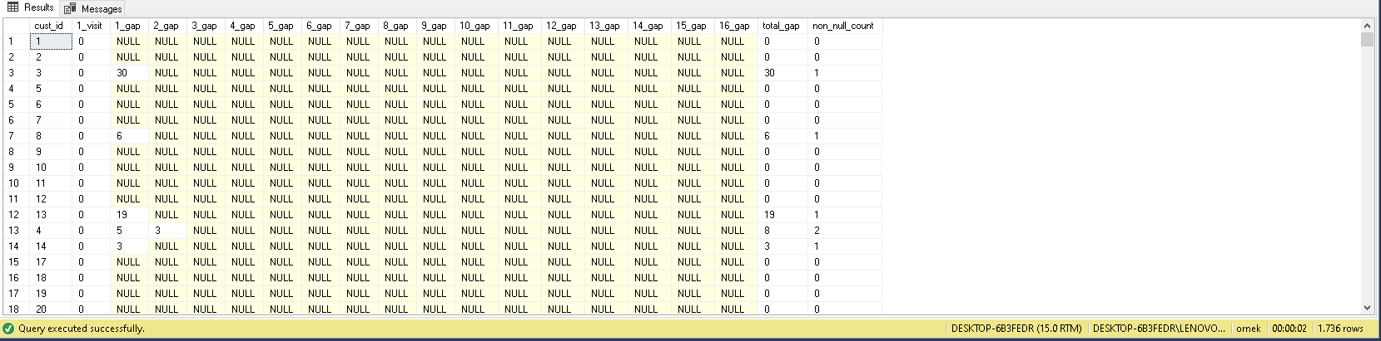SELECT

cust_id,

CASE WHEN avg_gap = 0 THEN 'Churn'

WHEN avg_gap = 1 THEN 'Regular'

WHEN avg_gap BETWEEN 2 AND 10 THEN 'Very Good'

WHEN avg_gap BETWEEN 11 AND 20 THEN 'Good'

WHEN avg_gap BETWEEN 21 AND 30 THEN 'Medium'

WHEN avg_gap BETWEEN 31 AND 40 THEN 'Bad'

ELSE 'Very Bad' END AS category_visitors

FROM

(

SELECT

*,

total_gap / CASE WHEN non_null_count = 0 THEN 1 ELSE non_null_count END avg_gap

FROM

total_gaps_non_null) AS subquery

ORDER BY

cust_id

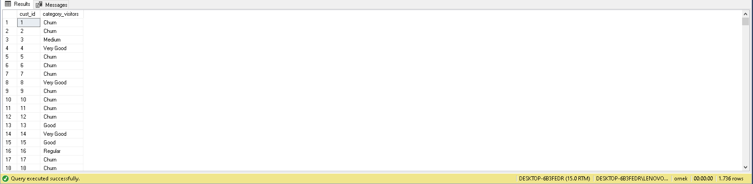

**Month-Wise Retention Rate**

**Find month-by-month customer retention rate*i* since the start of the business.**